**Course Project - Practical Activity**

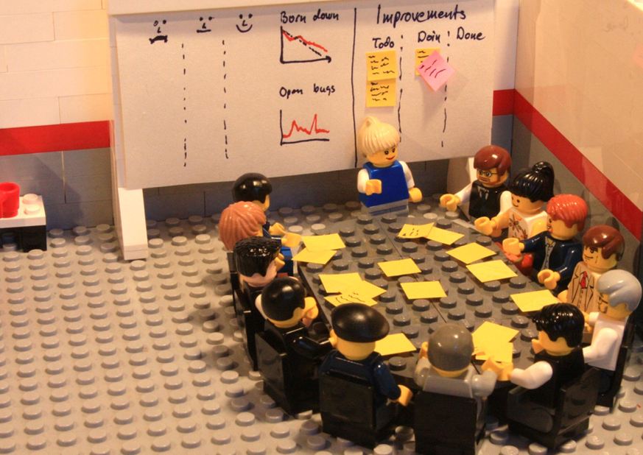

**The Course activity**which consists of you performing a Retrospective of your work week. You can do it for the week in progress or for the previous week, however you prefer. Do this exercise even if you don't have an Agile project yet or if you haven't started with Agile.

It's just**a fun and easy exercise which will allow you to put into practice a key Agile concept** you learnt in this course: **Retrospectives**.

**Enjoy the project! :)**